

**RESEARCH ORENTED PROJECT: 1**

**PREPARED BY: SATYAJIT PATEL (23MAS10009)**

**Problem Statement: AN OPTIMIZED MODEL TO CREATE TEAMS IN FANTASY CRICKET**

**ABSTRACT**

Fantasy cricket involves earning points based on players' performances in real cricket matches. In our proposed project, we utilized an optimized model to form teams within the virtual cricket domain. This involved incorporating a credit and points system along with various constraints. Unlike existing systems, our approach automatically generates teams based on specified conditions or user-selected criteria. Through testing in a real-time environment, our system demonstrated a higher success rate compared to teams manually created by users.

INDEX TERMS Cricket, Linear Programming, Binary Optimization, Team Selection, Machine Learning.

1. **Introduction**

A fantasy cricket league involves a group of participants registering individual teams to compete for the highest fantasy cricket points within the league. These leagues gain popularity during major Twenty20 events like IPL T20 and Big Bash T20 Matches [12].

The core business model entails charging a nominal fee for participating in fantasy games. The company utilizes the collected fees to create a fund, rewarding users with the most successful teams. Participants must adhere to budget constraints while building their teams for upcoming matches, selecting players from both participating teams, each with an associated cost. Minimum player requirements from each team and constraints on the number of batsmen, bowlers, all-rounders, and wicketkeepers must be met. At the end of the match, players receive scores based on their performance, and the user with the highest-scoring fantasy team wins a cash reward [14].

While some view fantasy sports as a form of sophisticated betting, legal challenges have been raised in India. However, the Supreme Court dismissed petitions, asserting that fantasy games require domain knowledge and analytical skills, distinguishing them from conventional betting. This study adopts a retrospective approach to Dream 11 team selection using Linear Programming, formulating the problem as a classic Knapsack problem with binary decision variables and implementing optimization through the PuLP library in Python.

1. **Literature Review**

The utilization of analytics and other mathematically intensive methods in cricket has been relatively limited. Despite a significant increase in the use of technology over the past decade, the adoption of analytics and optimization techniques has gained momentum only in recent years.

Historically, various ranking methods, such as those employed by Lemmer [1], Boorah and Mangan [2], Kimber and Hansford [3], and Damodaran [4], have been utilized for optimal team selection in cricket. These methods focused on specific performance indices like batting averages, strike rates, and the number of fours and sixes to assess a batsman. Some approaches, such as the one proposed by Damodaran [4], addressed calculating batting averages when a player remains not out. Additionally, Ovens and Bukiet [5], as well as Swartz et al. [6], explored mathematical models to optimize the batting order.

Traditionally, fantasy league players often relied on these ranking metrics to choose a team. However, the introduction of budget constraints and other limitations made a simple ranking method insufficient. Consequently, researchers have increasingly turned to machine learning and optimization techniques to assist fantasy league users in team selection. In this context, Farhana et al. [9] proposed a Support Vector Machine (SVM)-based solution that generates a ranked list of players based on their abilities, allowing users to select a playing 11.

So, viewed statically [12] and [14] method. It was bit complex and highly time taking and could be affected by human error because we have to enter data manually. On the other hand, the method which I will propose in following research paper is more convenient, and consumes less amount of time with accurate real time data. The reason being is in this method the data is provided in database in prior.

1. **Methodology**

The main steps of this project are:

1. Gathering data from the web through scraping.

2. Cleaning a bit of the collected data using Panda’s library.

3. Making improvements using Linear Programming using PuLP library

3.1 The connection between Fantasy Cricket and Linear Programming

Linear programming, which is a problem-solving method, can be applied to real-life situations, including Fantasy Cricket.

In Fantasy Cricket, building a team involves choosing the best players based on a specific goal. The challenge is to assemble a team that complies with all the rules set by the platform. This situation is ideal for solving with Linear Programming. The goal is to maximize the team's performance metric projection while staying within the budget (credits) and adhering to the constraints of team composition.

3.2 approach

In cricket, player stats cover things like matches played, total runs, batting strike rate, wickets taken by bowlers, overs bowled, and more. Most active players' stats are available. However, the key is figuring out which stats truly show a player's performance. Franchises aim to build a team of 11 players with excellent bowling, batting, and fielding skills while staying within budget and following certain rules. These rules include having a wicket-keeper and a captain [16].

Each player gets a label for identification. Using the data [17], we turn the team selection challenge into a multi-objective optimization problem as follows:

**F1(t) = signifies that player t belongs to the wicket-keeper list.**

**F2(t) = signifies that no two players in a team can be identical.**

**F3(t) = signifies that there are not more than four foreign players in a team.**

$f\left(t\right)= \sum_{t=1}^{11}{credit≤totalCredit}$

We aim to express our issue as a mathematical optimization problem. Typically, mathematical optimization problems consist of three fundamental elements:

• Decision Variables: These variables determine the final decisions in the optimization problem.

• Constraints: These are limitations imposed on the decision variables.

• Objective Function: It outlines what needs to be optimized in relation to the decision variables.

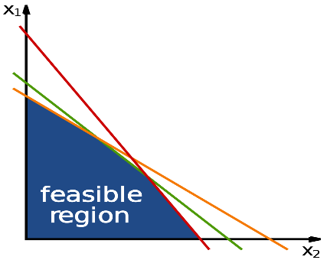

**Fig 1:** The doable area that follows all the rules in a Linear Program [18].

Flowchart:

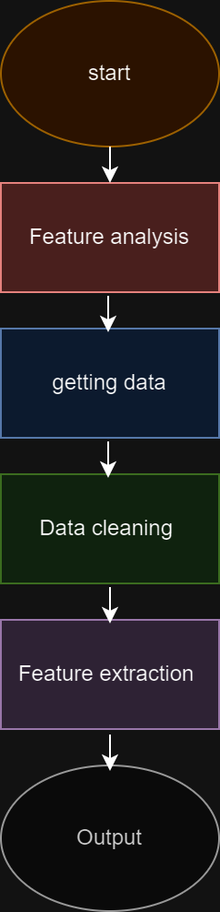

The process starts with feature analysis in which the column which are not required for the output is reduce. Due to this, the overall performance of the model is increase. After feature analysis, the data is collected for the dataset. The collected data is then cleaned by pandas python library so that the model can have appropriate data and whit this cleaned data model can generate accurate prediction. After data cleaning, all the important features are extracted form the model for prediction. And the end, the model produce the perfect 11 players on the basis of their performance.

1. **Results**

In this project, the model formed teams in the virtual cricket game using an optimized model in Fantasy Cricket. For the experiment purpose I have taken 2 sample teams (MI vs CSK) of 24 player. The results of the experiments show the optimal team or the best team based on specific criteria. We get to test the team generated by the model in a real-time setting against teams manually created by users in fantasy league like dream11 after the match.

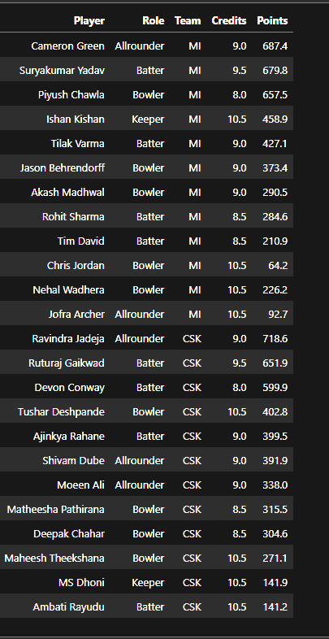

From this list of 24 players, this model produced the list of 11 players

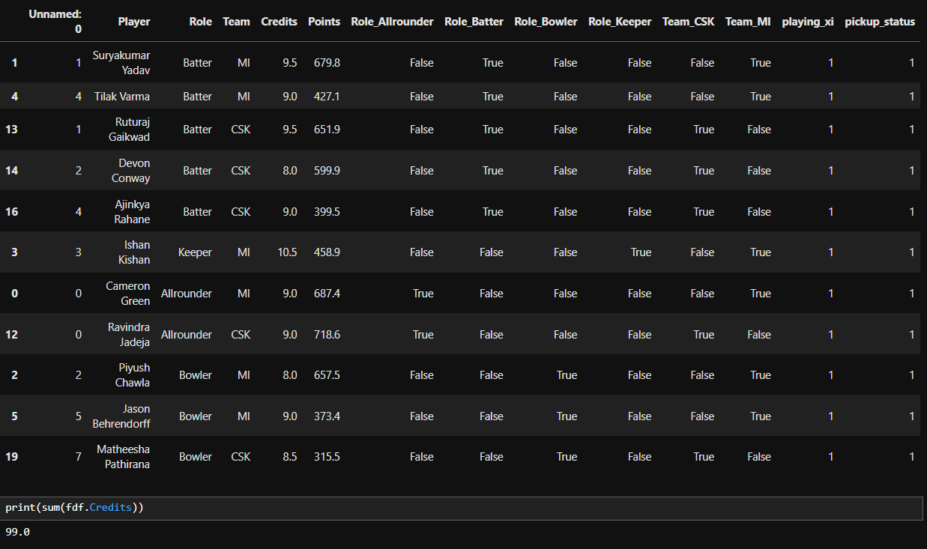

1. **Conclusion and Future Scope**

The paper introduces a new way to use Linear Programming with the PuLP library to predict the best team for a Dream 11 user. To make this model even better, we could add more features like pitch conditions, weather, and dew data, which are crucial in deciding the team's composition.

**6. Reference**

[1] Lemmer HH. A measure for the batting performance incricket players.SAfr J Res Sport Phys Educ Recreation26(1):55–64, 2002 [2] Borooah, V. K., an[1] Lemmer HH. A measure for the batting performance incricket players.SAfr J Res Sport Phys Educ Recreation26(1):55–64, 2002

[2] Borooah, V. K., and Mangan, J E, “The„Bradman Class‟: An Exploration of Some Issues in the Evaluation of Batsmenfor Test Matches, 1877–2006.”, Journal of Quantitative Analysis in Sports, 6 (3), Article 14, 2010.

[3] Kimber, A C and Hansford, A R, “A Statistical Analysis of Batting in Cricket,” Journal of Royal Statistical Society, 156, pp 443 –455, 1993.

[4] Damodaran, U, “Stochastic Dominance and Analysis of ODI Batting Performance: The Indian Cricket Team, 1989-2005,” Journal of Sports Science and Medicine, 5, pp 503 –508, 2006.

[5] Ovens M and Bukiet B. A mathematical modelling approachto one-day cricket batting orders.J Sports Sci Med5: 495– 502.Preston I and Thomas J. Batting strategy in limited overscricket.Statistician49(1): 95–106, 2006

[6] Swartz TB, Gill PS, Beaudoin D and de Silva BM (2006). Optimal batting orders in one-day cricket.Comput Opns Res33:1939–1950, 2006

[7] Lemmer HH (2006). A measure of the current bowling performancein cricket.S Afr J Res Sport Phys Educ

Recreation28(2): 91–103, 2006

[8] Lewis, A., “Extending the Range of Player-Performance Measures in One-Day Cricket,” Journal of Operational Research Society, 59, pp 729-742, 2008.

[9] Farhana Siddiqui, Hasan Phudinawala, Chetan Davale, Soham Pawar,” Innovative Idea for Playerelection usingSupport Vector Machine(SVM)” International Journal of Computer Sciences and Engineering, Vol. 7, Issue-4, pp.841-843, 2019

[10] C. Deep Prakash “A New Team Selection Methodology using Machine Learning and Memetic Genetic Algorithm for IPL-9”, International Journal ofElectronics, Electrical and Computational System Volume 5 –Issue.4, April 2016

[11] Sharp, Gary & Brettenny, Warren & Gonsalves, John & Lourens, Michelle & Stretch, R. Integer optimisation for the selection of a Twenty20 cricket team. Journal of the Operational Research Society. 62. 10.1057/jors.2010.122, 2011

[12]. An optimized model to create teams in fantasy cricket Article in SSRN Electronic Journal · January 2021 DOI: 10.2139/ssrn.3853704

[13]. Fantasy Cricket — Application of Linear Programming, A step-by-step guide using Python(PuLP package), Lakshmi Ajay, Article in medium.com.

[14]. Saurav Singla et al, Integer Optimisation for Dream 11 Cricket Team Selection, International Journal of Computer Sciences and Engineering, November 2020 DOI: 10.26438/ijcse/v8i11.16.

[15] Fantasy Rules: <https://www.dream11.com/fantasy-cricket/point-system>

[16] IPL 2023 All Teams: <https://www.insidesport.in/wp-content/uploads/2022/03/d03936c4-44d6-41ca-a24b-fc8a293989cb.jpg>

[17] IPL 2023 Data: <https://www.espncricinfo.com/series/indian-premier-league-2023-1345038/most-valuable-players>

[18] linear programming image:

<https://upload.wikimedia.org/wikipedia/commons/0/0c/Linear_Programming_Feasible_Region.svg>